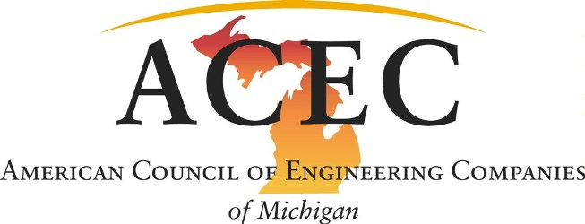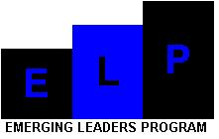

Please make your hotel reservations directly with the hotels listed below. Make your reservation in the ACEC Michigan ELP block of rooms by the release date noted. You will need to guarantee all rooms with a credit card.

September 6-7, 2018
Radisson Hotel Lansing
111 N. Grand Avenue
Lansing, MI 48933
800.333.3333 or 517.482.0188
www.radisson.com/lansingmi
Promotional Code: ACE918
Room Rate: $127.95
Room Release Date: August 7, 2018
October 11-12, 2018
Doubletree Suites by Hilton Detroit Downtown – Fort Shelby
525 West Lafayette Boulevard
Detroit, MI 48226
313-963-5600
Room Rate: $155
Booking Link
Room Release Date: September 11, 2018
November 26-27, 2018
Courtyard by Marriot
11 Monroe Avenue NW
Grand Rapids, MI 49503
(877) 901-6632
https://book.passkey.com/e/49609918
Room Rate: $199
Room Release Date: October 26, 2018

